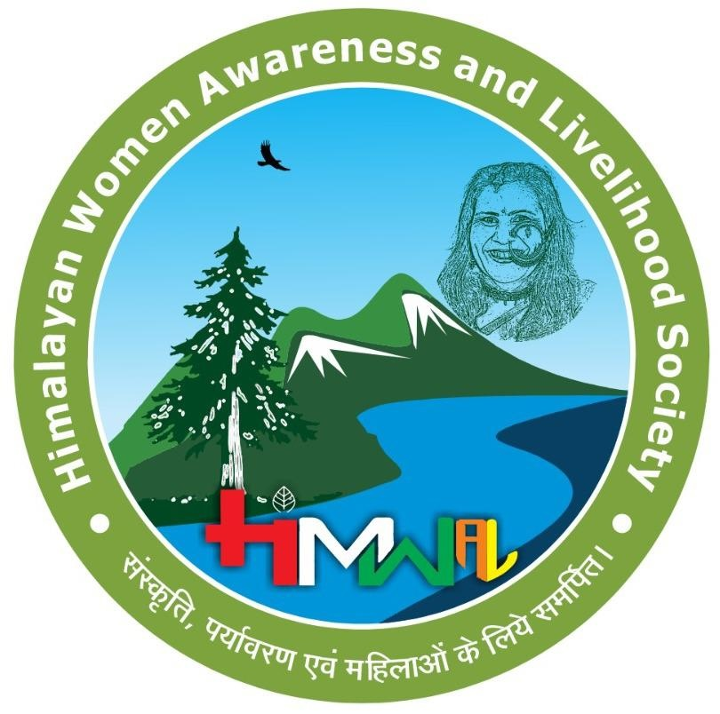
HIMWAL SOCIETY
Himalayan Women Awareness and Livelihood Society
संस्कृति, पर्यावरण एवं महिलाओं के लिये समर्पित।
PRODUCT CATALOGUE & PRICE LIST
We empower Pahadi women in rural Uttarakhand by providing sustainable livelihood opportunities through the sale of pure, organic, home-made products.
🌿 All products are pure organic and home made 🌿
PICKLES अचार
Product | हिंदी नाम | Qty / Unit | Price (₹)
Garlic Pickle | लहसुन अचार | 1 kg | 425
Mixed Vegetable Pickle (Carrot, Radish, Ginger, Cauliflower) | मिक्स अचार | 1 kg | 350
Lemon Pickle | नींबू अचार | 1 kg | 375
Stuffed Chilli Pickle (Red / Green) | भरवां मिर्च अचार | 1 kg | 400
Prices may vary depending on the current market price of ingredients.
INSTANT DRIED CHUTNEY POWDER चटनी पाउडर
Product | हिंदी नाम | Qty / Unit | Price (₹)
Bhangjeera Flavour | भंगजीरा चटनी पाउडर | 1 kg | 450
Soyabean & Curry Patta Flavour | सोयाबीन करी पत्ता चटनी पाउडर | 1 kg | 400
Wheat & Pudina Flavour | गेहूं पुदीना चटनी पाउडर | 1 kg | 400
Sesame Flavour | तिल चटनी पाउडर | 1 kg | 450

FLAVOURED SALT नमक
Product | हिंदी नाम | Qty / Unit | Price (₹)
Hemp Seed Flavour | भांग नमक | 1 kg | 650
Flax Seed Flavour | अलसी नमक | 1 kg | 650
Bhangjeera Flavour | भांगजीरा नमक | 1 kg | 680
Garlic / Coriander Flavour | हरा नमक | 1 kg | 550
Sesame Seed Flavour | तिल नमक | 1 kg | 650
Timur Flavour | तिमुर नमक | 1 kg | 680

LENTIL BADI बड़ी
Product | हिंदी नाम | Qty / Unit | Price (₹)
Urad Dal Badi | नाल बड़ी | 1 kg | 350
Moong Dal Badi | मूँग दाल बड़ी | 1 kg | 300
Gehat Dal Badi | गेहत दाल बड़ी | 1 kg | 350
Mixed Dal Badi (Lobiya, Moong, Gehat, Urad) | मिक्स दाल बड़ी | 1 kg | 325

MILLET & FLOUR PRODUCTS रोंट
Product | हिंदी नाम | Qty / Unit | Price (₹)
Millet Roti Flour | रोंट (मडुवा) | 1 kg | 380
Wheat Flour | गेहूँ का आटा | 1 kg | 260
Manduwa Ladoo | मडुवा लड्डू | 1 kg | 320

ORGANIC PRODUCTS FROM THE HIMALAYAS
Product | हिंदी नाम | Qty / Unit | Price (₹)
Kidney Bean (Chakrata Rajma) | चकराता राजमा | 1 kg | 320
Rajma Chhemi | राजमा चेमी | 1 kg | 240
Gehat | गेहत | 1 kg | 220
Black Gram | उड़द दाल | 1 kg | 180
Yellow Soyabean | सोयाबीन | 1 kg | 100
Black Soyabean | भट्ट | 1 kg | 190
Wild Mustard | जख्या | 1 kg | 220
Perilla Seeds | भंगजीरा | 1 kg | 400
Pahadi Sesame Seeds | तिल | 1 kg | 190
Faran | फरण | 1 kg | 1000
Roasted Soyabean Flour | सोयाबीन चौसा | 250 g | 70
Roasted Urad Dal | उड़द दाल चौसा | 250 g | 80
Dried Apple Slice | सेब सूक्सू | 120 g | 30
Choru | चोरू | — | —
Homemade Organic Medicinal Dhoop (8 pieces) | हर्बल धूप | 1 packet | 25
Gangotri Gangajal | गंगोत्री गंगाजल | 1 litre | 150

HANDCRAFTED PRODUCTS (Showcasing the Cultural Heritage of Uttarakhand)
Product | हिंदी नाम | Qty / Unit | Price (₹)
Hand-painted Key Chains | — | per piece | 50–60
Hand-painted Fridge Magnets | — | per piece | 100
Canvas Paintings | — | varies | on size
Crochet Keychains | — | per piece | on request
Crochet Bags & Other Items | — | varies | on request
Prices for canvas paintings, crochet items, and select handcrafted pieces are made to order and vary by size / design — please contact us for a quote.

Thank you for supporting Himalayan women's livelihoods.

GET IN TOUCH
📧 contact.himwal@gmail.com
📞 +91-9027782863 | +91-7454097237
📍 Lane No. 6 (E), THDC Colony, Tea Estate Banjarawala, Dehradun – 248121, Uttarakhand
FOLLOW US
Instagram: himwal.23 | X: @HIMWAL_Society | YouTube: HIMWAL
Facebook: HIMWAL SOCIETY | LinkedIn: Himalayan Women Awareness and Livelihood Society (HIMWAL)
Join us as a volunteer and share your suggestions via email.

